Prescriptions -The easiest way to order your repeat prescription is by using the [NHS App](https://www.nhs.uk/nhs-app/), this shows you all your repeat medicine and dosages and you can choose the ones you need.Alternatively you can request your prescriptions using;

[Prescription Ordering Direct (POD) service - NHS Shropshire, Telford and Wrekin](https://www.shropshiretelfordandwrekin.nhs.uk/your-health/where-to-get-advice-and-help/prescription-ordering-service/)

The POD can be contacted via telephone on 0333 358 3509, Monday to Friday between 9am and 5pm. It is a large call centre with 30+ handlers to deal with your request. They can also be contacted using their form or by email [shropshire.pod@nhs.net](mailto:to shropshire.pod@nhs.net)

*Please note: we do not take repeat prescription requests over the phone or email.*

Dispensing Patient Prescriptions **-** We are fortunate to have a Dispensary at the practice which means we can dispense medication to some of our patients. Legislation means that we can only dispense your medication is you live more than three miles (by road) from the chemists in Albrighton or Shifnal. The dispensary opening hours are: 08.30 to 6.00 pm daily.

If you are a dispensing patient you can use [NHS App](https://www.nhs.uk/nhs-app/) or [POD](https://www.shropshiretelfordandwrekin.nhs.uk/your-health/where-to-get-advice-and-help/prescription-ordering-service/) to request your repeat prescriptions or you can contact Dispensary by phone 01902 372301.

Home delivery of medications for dispensing patients can be arranged. Please contact dispensary if this service is required.

Your Data - We are committed to operating in a way that complies fully with the provisions of the General Data Protection Regulation (GDPR) and the Data Protection Act 2018. We recognise that the personal data legitimately required in order to carry out our business must be collected, processed, stored and disposed of fairly, lawfully and with due regard to confidentiality. We fully respect your privacy.

If you have any questions about your data or how we deal with it please contact the practice and get in touch with us by clicking on the Contact Us links available on this website.

Accessible Information / Reasonable adjustment flag

We want to get better at communicating with our patients. We want to make sure you can read and understand the information we send you. If you find it hard to read our letters or if you need someone to support you at appointments, please let us know.

The Reasonable Adjustment Flag is a national record that shows a person needs accommodations and may include details about their impairments and necessary adjustments.If you are a patient or carer of a patient who you feel may benefit from a Reasonable Adjustment Flag on your medical records please let a member of the practice team know. We will not add a Reasonable Adjustment Flag to your record without your consent.

Non NHS Work - We are happy to provide non-NHS work including medicals (e.g. HGV medicals), private sick notes and holiday travel insurance forms. A fee will be charged and payment is required before the work is carried out. Reception Staff will advise you what the fee will be. The fee will be subject to VAT.

Travel Health - If you require NHS travel vaccinations, we are happy to provide these. However, we are unable to give travel advice.

This practice leaflet provides a brief overview of the practice only, for more detailed information please consult our website www.albrightonmedicalpractice.nhs.uk.

On the website you will find our surgery policies and procedures.

If you do not have internet access we are happy to print this information off for you.

Albrighton Medical Practice

A Guide to our services

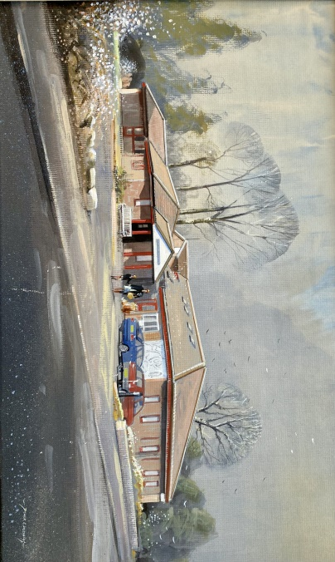

Albrighton Medical Practice

Shaw Lane

Albrighton

Wolverhampton

WV7 3DT

Tel. 01902 372301

[www.albrightonmedicalpractice.nhs.uk](http://www.albrightonmedicalpractice.nhs.uk)

WELCOME Albrighton Medical Practice welcomes you to the Surgery and we hope that you find the enclosed information useful. More information is available on our website;

Opening Hours:The surgery is open 8.00 am to 6.00 pm Monday to Friday (excluding bank holidays). Extended opening hours are provided on Monday evenings 6.30pm to 8.30 pm and every fourth Saturday. These are for booked appointments only. No emergency provision is available during this time at the surgery.

**Call 999 in a medical or mental health emergency. This is when someone is seriously ill or injured and their life is at risk.**

If you need help when we are closed If you become ill and your GP surgery is closed, please call.NHS 111 (please telephone 111) provides out of hours cover to our patients. NHS 111, tel. 111, or NHS Choices www.nhs.uk, provides health information 24 hours a day.

The Practice Team

Practice Manager - Mrs. Bridget Laffoley

Partners

Dr Annette Quilter MBChB (Birmingham 2008), MRCGP, DRCOG, DFRSH

Dr Prabhjot Uppal MBBS (2000), DRCOG, MRCGP, DFSRH

Dr Clare Hurst BSc, MBChB, MRCGP, MSc

Dr Emily Ward MBChB, MRCGP, DRCOG

Dr Matthew Bird MBChB (Birmingham 1999), MRCGP, MRCS (Edinburgh), DCH, DRCOG, DFFP

Salaried GPs

Dr Jessica Harvey MRCGP, MBBS, BSc Hons

Dr Margaret Mascarenhas MBChB with Honours (Birmingham 2011), MRCGP, MRes, BSc with First Class Honours, DRCOG, PGCert

Dr Rupinder Bhandal MBChB, MRCGP, DRCOG

Dr. Onyinye Claire Ibekwe MBBS, MRCGP

Nursing Team

Practice Nurses Lindsey Harris, Hayley Avery, Rebecca Podmore.

Nurse Associate Sue Mumford,

Health Care Assistants Tracey Gamble, Meegan Webb.

Reception Team

Admin Team

Dispensers

Community Care Coordinator

ARRS staff - Physician Associate, Clinicial Pharmacists, First Contact Physiotherapist, Healthy lives advisor

Training Practice - We are proud to be a training practice, helping to develop healthcare professionals of the future. Being a training practice allows us to reflect on our our knowledge, skills and performance. We have medical students from Keele University and also GP Registrars during their training. Each trainee receives appropriate levels of supervision. You maybe be offered an appointment with a trainee, you will always have the opportunity to decline this if you do not feel it is appropriate for you.

Appointments - We want to make the process of booking an appointment with your GP practice as easy and fair as possible. We use a system called AccuRx Total Triage

How do I contact the practice/request an appointment? Online request - this is the preferred method, you can still contact the surgery by telephone (01902 372301) or in person and Reception will help you.

Accurx Total Triage is our online consultation platform accessible via NHS App or clicking on the link on our website. It removes the need to hang on the telephone and avoids the 8 am rush.

What happens to my request?

Medical requests are triaged by a GP, who will decide on the most appropriate action and timescale, which may include, telephone or face to face appointment, advice or signposting to another service.We will respond to medical requests on the same day, admin requests are viewed and directed to the most appropriate team member for action, we will respond to these within five working days.

Home Visits - If you need to be seen but are unable to get to the surgery, you may request a home visit. Please contact the surgery before 10.30 am. Home visits will be attended to at lunchtime.

Please Note: Home visits are for the genuinely housebound, serious and terminally ill patients. Please do not abuse this service.

Text Messages - Please be aware we may contact you by secure text message in response to your request, to remind you about appointments or provide health information (such as upcoming flu vaccinations).

Registration - Our practice covers a semi rural population including the villages of Albrighton, Pattingham, Badger, Beckbury, Tong, Tong Norton, Worfield, Chesterton and surrounding areas. A map is available on our website that shows detail of our practice boundary. Anyone who lives within the practice boundary is allowed to register with the practice. Including the homeless and traveller communities. Patients wishing to register must attend the surgery and complete the appropriate form and present valid proof of address or in the case of a new born baby the form issued by the registrar of births and deaths.

Named GP - As a Practice we are required to allocate all patients with a Named GP (Registered GP).This does not prevent any patient from seeing any GP within the practice or change the GP normal

Services -The practice offers the following services to its patients in addition to standard GP services.

Antenatal, Blood tests, Cervical Screening, Citizens Advice Bureau, Community Care Coordinator, Contraception, Ear Irrigation, Immunisations, Joint Injections, Minor Surgery, Talking therapies

Young People - There is specific information for young people available on our website.

Complaints - We make every effort to give the best service possible to everyone who attends our practice. However, we are aware that things can go wrong resulting in a patient feeling that they have a genuine cause for complaint. To pursue a complaint please contact the practice manager who will deal with your concerns appropriately. Our complaints protocol is available on our website.

Disabled Access - Disabled access is via the front entrance. All clinical areas have disabled access. If you have any special requirements please inform the reception staff. We have a hearing loop for those that need it.